Target audience 1
User Requirements 2
Data Requirements 2
Control Tables and Form Designs 6
Login Form 6
Data Entry Form 7
Quiz form 10
Reaction Test form 13
Reports form 15
Validation 17
Login Form 17
Data Entry Form 17
Quiz Form 17
Reaction Form 17
Report Form 17
Pseudocode 19
Login Form 19
Data Entry form 20
Quiz form 24
Reaction test form 27
Reports form 31
Testing 34
Corrective Action 38
Evaluation 44
User Requirements 44
Performance During Testing 46
Performance and Robustness 46

Target audience
The target audience of this software is the students in Bayside high School allowing them to log into their school trip and complete a quiz and reaction test giving the group that they will be in on the school trip and storing the data that they enter in a text file to be viewed at a later date. The people that will be using this software are those who wish to go on the school river trip as this program is designed to help them sign up for the trip and find out what group they are in.

User Requirements
- The user has to have a password and their username to get passed the log in form.
- The user has to have the number of lengths they did for attempt 1 and 2 so they can average it so it can go towards their total score and their group.
- The user must have all of the correct details that need to be added to the data entry form.
- The user must be able to get pop ups to tell them what they did wrong or tell them what they are supposed to do and progress with buttons.
- The user must be able to answer all questions in the program.
- The user must be able to change the form by pressing buttons or by interacting with the other features such as combo boxes.

Data Requirements
 | Data item | Data type | Sample Valid data | Function of data items
1. | DisplayedResult | integer | 5 | Stores the final score for the quiz so that it can be used later to find the group of the user
2. | ReactionTestScore | integer | 7 | Stores the final result of the reaction test so that can be used to find the group of the user in the data entry form.
3. | ChallengeComplete | Boolean | true | The value changes form false to true after the reaction test form has been complete and enables all of the controls on the data entry form.
4. | TotalScore | integer | 7 | This value is the result of both the reaction test score and the quiz score combined to find the group of the user.
5. | btnCounter | integer | 1 | Stores the number of buttons pressed for the second question so that when 2 buttons are pressed the rest of the buttons for the question are disabled.
6. | Score1 | integer | 5 | The result of Score1 is dependant on what the user got for their average lengths and goes towards their GroupScore.
7. | Score2 | integer | 3 | The result of Score2 is dependant on how the user did in their quiz and reaction test and goes towards their GroupScore.
8. | group | string | advanced | This stores the group that the user got into based on their GroupScore and enters it into the Pupil Info text file.
9. | AverageLengths | integer | 12 | This stores the number of lengths that the user could do on average so it can be used to find their group.
10. | GroupScore | integer | 10 | This is based on what Score1 and Score2 are when they are added up and depending on what it is the user will be sorted into a group.
11. | error | string | Nothing entered in attempt 1 | This is dependant on if the user enters any of their details incorrectly and if it is not blank then a message box will pop up.
12. | valid | Boolean | true | If valid is false, then the data entered will not be accepted and will have to be re-entered.
13. | average | integer | 14 | It will store the value of the average of the two attempts and enter it into tbxAverage.
14. | Error | string | Please enter your surname. it cannot be longer than 15 letters | If the user has entered the data incorrectly an error message will appear depending on what was entered wrong.
15 | group | string | Group(); | This enters the group that the user has been sorted into the text file.
16. | FilePath | string | Pupil info.txt | This stores the file address so that all of the required data can be put onto the file.
17. | countdown | integer | 14 | This counts down the time and when it reaches 0 it disables all of the picture boxes in the form.
18. | Pupil | string |  | Allows the data stored to be split up when it is read form the pupil info file.
19. | PupilDetails | string |  | Split the data in the list view into a list depending on where a “~” is.
20. | ascending | Boolean | true | This sorts the data into alphabetical order or from highest to lowest when a column is clicked.

Control Tables and Form Designs

Login Form
Number | Control name | Control Type | Purpose of Control | Control Value
1 | lblTitle | label | Output- Displays the school’s name. | Bayside Highschool trip login
2 | pbxLogo | Picture box | Output- Displays the school’s logo. | Bayside logo.png
3 | lblUsername | label | Output- Displays where the user should put their username. | Username
4 | tbxUsername | textbox | Input- Where the user should put the username.
5 | lblPassword | label | Output- Displays where the user should enter their password. | Password
6 | tbxUsername | textbox | Input- The password should be entered here.
7 | btnEnter | button | Input- Allows the user to enter their username and password. | Enter
8 | btnHelp | button | Input- Allows the user to access the help tab. | Help

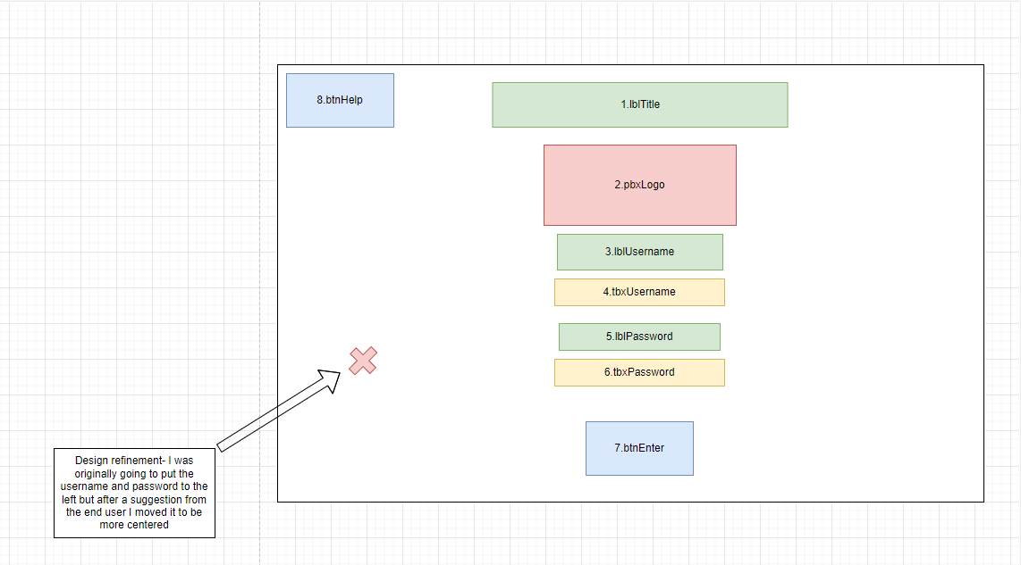

Data Entry Form
Number | Control Name | Control Type | Purpose of control | Control Value
9 | LblDataEntryTitle | label | Output- To display the title of the form. | Data Entry Form
10 | LblFirstName | label | Output- To show the user where to put their first name. | First name
11 | TbxFirstname | Text box | Input- Allows the user to enter their name.
12 | lblYearGroup | label | Output- Shows where to enter their year group. | Year Group
13 | TbxYearGroup | Text box | Input- Allows the user to enter their year group.
14 | lblSurname | label | Output- Displays to the user where to enter their Surname. | Surname
15 | tbxSurname | Text box | Input- Gives the user a space to type their surname.
16 | lblGender | label | Output- Displays where the user should type their gender. | Gender
17 | tbxGender | Text box | Input- Allows the user to enter their gender.
18 | BtnHelp | Button | Input- Brings up a window to help the user when clicked. | Help
19 | btnSubmit | Button | Input- Lets the user submit their answers. | Submit
20 | PnlDataEntry | panel | Output- Houses the labels and buttons to find the average for their attempts.
21 | pbxLogoDataEntry | Picture box | Output- Displays the school’s logo. | Bayside logo.png
 | btnQuiz | Button | Input- Brings the user to the quiz. | Quiz
23 | LblQuizResult | Label | Output- Displays where the quiz result is. | Quiz Result:
24 | lblQuizResultDisplayed | label | Output- Displays the quiz result. | 0
25 | lblReactionTime | label | Output- Displays where the reaction time is. | Reaction time
26 | lblReactionTimeDisplayed | label | Output- Displays the users reaction time. | 0
27 | lblAttempt1 | label | Output- Shows where to enter the number of lengths done on attempt 1. | Attempt 1
28 | LblAttempt2 | label | Output- Shows where to enter the number of lengths done on attempt 2. | Attempt 2
29 | TbxAttempt1 | Text box | Input- Where the user enters the number of lengths done on attempt 1.
30 | tbxAttempt2 | Text box | Input- Where the user enters the number of lengths done on attempt 2.
31 | BtnAverage | button | Input- When pressed finds the average lengths of the attempts. | Average
32 | lblAverage | label | Output- Displays where to find the average. | Average lengths
33 | tbxAverage | Text box | Input- Displays to the user where to put the average.
59 | btnViewReport | button | Output- When pressed by the user will bring them to a new form where they can view their report. | View report
86 | lblTotalScore | label | Input- Displays where to find the total score. | Total Score:
87 | lblTotalScoreDisplayed | label | Input- Displays the users total score in both the reaction test and quiz. | 0
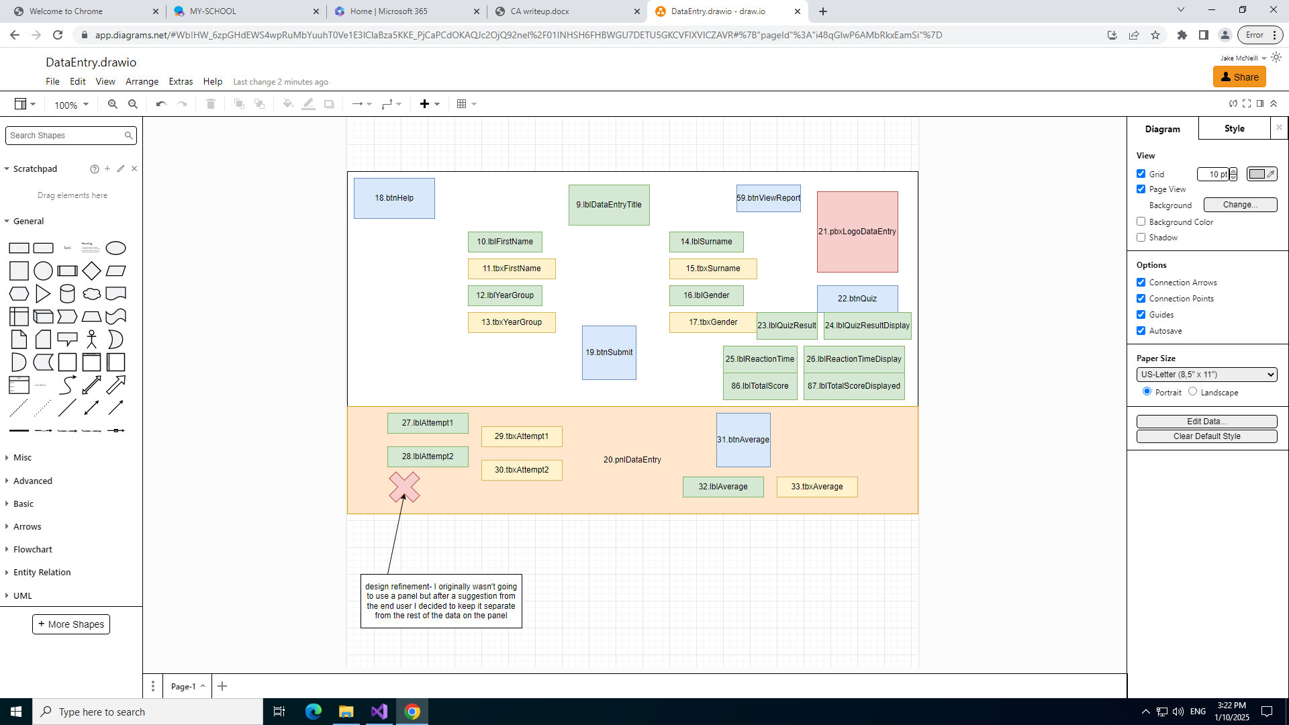

Quiz form
Number | Control Name | Control Type | Purpose of control | Control Value
34 | lblQuiz | label | Output Displays the name of the form. | Quiz
35 | LblResult | label | Output- Displays where to find the quiz result. | Quiz Result:
36 | lblDisplayedResult | label | Output- Displays the result of the quiz. | 0
37 | PnlQuestion1 | panel | Output- Hold question 1.
38 | PnlQuestion2 | panel | Output- Hold question 2.
39 | PnlQuestion3 | panel | Output- Hold question 3.
40 | PnlQuestion4 | panel | Output- Hold question 4.
41 | PnlQuestion5 | panel | Output- Hold question 5.
42 | LblQuestion1 | label | Output- Shows question 1. | How can cold water affect your swimming ability?
43 | CbxQuestion1 | Combo box | Input- Allows the user to choose their answer for question 1.
44 | lblQuestion2 | label | Output- Shows the user where question 2 is. | Fill in the gaps
45 | LblTextWithGaps | label | Output- Displays the first line of question 2. | If someone is in trouble you should______.
46 | LblTextWithGaps2 | label | Output- Displays the second line of question 2. | Always follow the rules set by the______.
47 | btnJumpInAndHelp | Button | Input- Allows the user to answer the question and fill in the blanks. | Jump in and help
48 | btnCallForHelp | Button | Input- Allows the user to answer the question and fill in the blanks. | Call for help
49 | btnTeachers | button | Input- Allows the user to answer the question and fill in the blanks. | Teachers
50 | btnSafetySigns | button | Input- Allows the user to answer the question and fill in the blanks. | Safety signs
51 | LblQuestion3 | label | Output- Displays question 3. | open water isn't dangerous to swim in with others around.  Is this statement True or False.
52 | btnFalse | button | Input- Allows the user to answer false. | False
53 | btnTrue | button | Input- Allows the user to answer true. | True
54 | lblQuestion4 | label | Output- Displays question 4. | What could you throw to someone to help them float?  something Heavy or Light.
55 | TbxQuestion4 | Text box | Input- Allows the user to type the answer to question 4.
56 | btnQuestion4 | button | Input- Allows the user to submit their answer to question 4. | enter
57 | LblQuestion5 | label | Output- Displays question 5. | What is the symbol for dangerous deep water?
58 | PbxOption3 | Picture box | Input- Allows the user to select the picture as the answer to question 5.
60 | btnNext | button | Output- When pressed brings the user to the reaction test. | Next
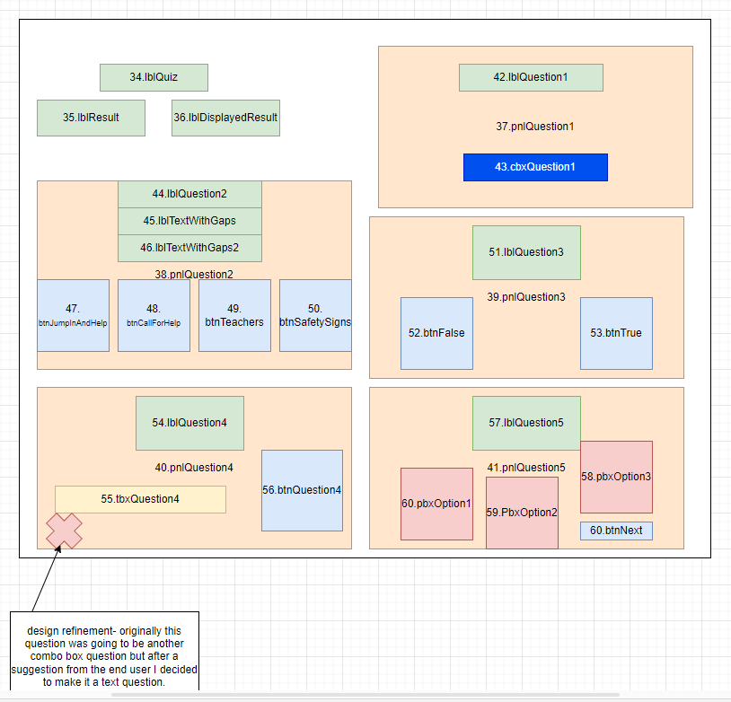

Reaction Test form
61 | btnBackToDataEntry | button | Output- When pressed brings the user back to the data entry form | Back to Data Entry
63 | LblReactionTest | label | Input- Tells the user what form they are on | Reaction test
64 | lblTask | label | Input- Tells the user what to do | Click on the red ticks and the green x’s
65 | lblReactionTestResult | label | Input- Shows the user where to see their result | Score -
66 | lblDisplayedReactionResult | label | Input- Displays the users result | 0
67 | lblTimer | label | Input- Displays where to see the time they have left | Time -
68 | lblTimeDisplayed | label | Input- Tells the user how much time they have left | 15
69 | pbx1 | Picture box | Output- Depending on if the image fits the task, it will either award or take away a point. | RedTick.jpg
70 | pbx2 | Picture box | Output- Depending on if the image fits the task, it will either award or take away a point. | GreenTick.jpg
71 | pbx3 | Picture box | Output- Depending on if the image fits the task, it will either award or take away a point. | RedX.jpg
72 | pbx4 | Picture box | Output- Depending on if the image fits the task, it will either award or take away a point. | GreenX.jpg
73 | pbx5 | Picture box | Output- Depending on if the image fits the task, it will either award or take away a point. | GreenTick.jpg
74 | pbx6 | Picture box | Output- Depending on if the image fits the task, it will either award or take away a point. | RedX.jpg
75 | pbx7 | Picture box | Output- Depending on if the image fits the task, it will either award or take away a point. | GreenX.jpg
76 | pbx8 | Picture box | Output- Depending on if the image fits the task, it will either award or take away a point. | RedTick.jpg
77 | pbx9 | Picture box | Output- Depending on if the image fits the task, it will either award or take away a point. | RedX.jpg
78 | pbx10 | Picture box | Output- Depending on if the image fits the task, it will either award or take away a point. | GreenX.jpg
79 | pbx11 | Picture box | Output- Depending on if the image fits the task, it will either award or take away a point. | RedTick.jpg
80 | pbx12 | Picture box | Output- depending on if the image fits the task, it will either award or take away a point. | GreenTick.jpg
81 | pbx13 | Picture box | Output- Depending on if the image fits the task, it will either award or take away a point. | GreenX.jpg
82 | pbx14 | Picture box | Output- Depending on if the image fits the task, it will either award or take away a point. | RedTick.jpg
83 | pbx15 | Picture box | Output- Depending on if the image fits the task, it will either award or take away a point. | GreenTick.jpg
84 | pbx16 | Picture box | Output- Depending on if the image fits the task, it will either award or take away a point. | RedX.jpg
85 | btnHelp | button | Output- When pressed tells the user what they are supposed to do on the form. | Help
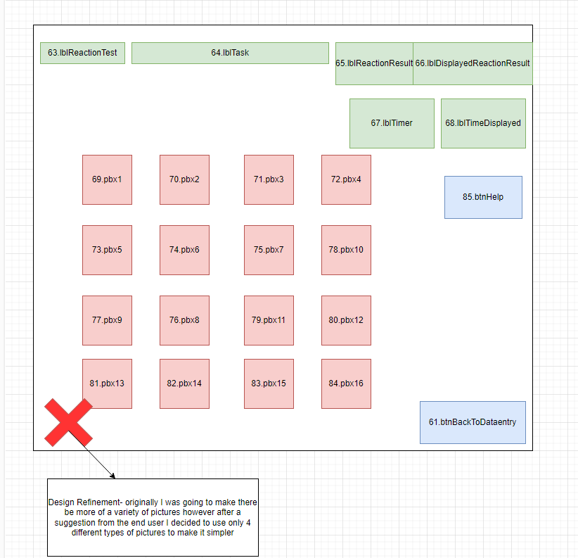

Reports form
62 | btnBack | button | Output- When pressed brings the user back to the data entry form from the reports form. | Back
86 | ltvReport | List View | Unput- Allows the user to see what others got for their total score and their group.
87 | lblReports | label | Input- Tells the user what form they are on. | Reports
88 | btnViewAll | Button | Output- Causes the list view to display all results when pressed. | View all
89 | cbxReport | Combo box | Output- Allows the user to see the results of people in specific groups. | advanced  swimmer  Non-swimmer
90 | pbxReport | Picture box | Input- Displays the school logo. | Bayside logo.png
91 | cbxYearGroup | Combo box | Output- Allows the user to filter the data to only show people in certain year groups. | 11  12  13  14
92 | btnHelp | button | Output- Displays a message box which explain the form to the user.
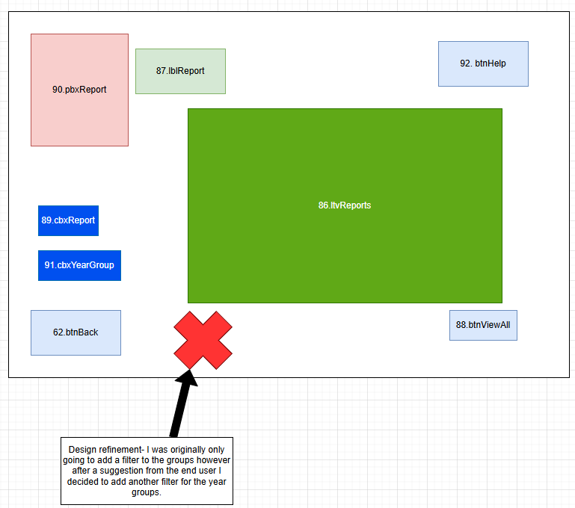

Validation

Login Form
- Presence check – tbxUsername cannot be left blank.
- Presence check- tbxPassword cannot be left blank.

Data Entry Form
- If statement- surname and first name cannot be longer than 15 letters so that none of the names are unrealistic.
- Range check- The year group has to be a number between 11 and 14 for it to be accepted and not cause an error.
- If statement- The gender textbox by the user for it to be accepted.
- If statement- If the file exists, the details will be written on it.
- If statement- If there is no error the details will be submitted.
- Presence check – tbxGender, tbxFirstName, tbxYearGroup and tbxSurname cannot be left blank otherwise an error message will appear, and they won’t be able to continue.
- Presence check- Both of the attempt textboxes have to be filled in to get an average.
- Type check- There can’t be letters in the attempt boxes as it will not be accepted, and an error message will appear.
- Everything in the form is disabled when it loads except for the reports, quiz and help button.

Quiz Form
- Presence check- CbxQuestion1 has to have an answer selected to continue in the quiz form.
- Range check- Only two of the buttons can be pressed for question 2 before the rest are disabled and the next question in enabled.
- If statement- “light” has to be entered into the textbox for question 4 or else the question will be incorrect.
- pnlQuestion3 Is disabled after either the true or false button was clicked.
- pnlQuestion5 Is disabled when one of the three picture boxes are selected.
- All of the questions are disabled at the start except for question 1 and the rest of the questions were only enabled when the questions were answered.

Reaction Form
- If statement- If the timer is at 0 all of the picture boxes will be disabled so that no more can be selected.
- All of the picture boxes are disabled when they are selected so that the same question cannot be selected twice to get more score.

Report Form
- Presence check- If the list view is clear the combo boxes will be able to sort through the data to view only the wanted entries.

Pseudocode

Login Form
btnLogin
when btnLogin is clicked
if tbxUsername is Username1 and tbxPassword is password1
show messagebox saying “Login successful”
hide frmLogin
move to data entry form
else
show messagebox saying “incorrect Username or Password entered”

when btnHelp is clicked
show messagebox saying "username =Username1 and password =password1"

Data Entry form
Score 1 is 0
Score 2 is 0
Group
Average lengths is tbxAverage
If average lengths is greater than or equal to 15
Score 1 is 5
Else if average lengths is between 7 and 14
Score 1 is 3
Else
Score 1 is 1
Total Score is lblTotalScoreDisplayed
If total score is greater than or equal to 12
Score2 is 5
Else If total score is between 6 and 11
Score2 is 3
Else
Score2 is 1
Group score is score 1 plus score 2
If group score is greater than or equal to 8
Group is advanced
Else if group score is between 6 and 8
Group is swimmer
Else
Group is non-swimmer
Then return group

When loading form data entry
If quiz and reaction test are not complete
Disable all features other than the quiz, help, and report button
Else
Enable all features other than the quiz button
lblQuizResultDisplayed is quiz result
lblReactionTimeDisplayed is Reaction test result
lblTotalScoreDisplayed is the total score

when btn average is clicked
error is blank
valid is true
average is 0
if attempt 1 is blank
error is "Nothing entered in attempt 1"
if attempt 2 is blank
error is "Nothing entered in attempt 2"
for each character in attempt 1
if a character is a letter
valid is false
for each character in attempt 2
if a character is a letter
valid is false
if valid is false
error is “only include numbers”
if error is blank
average attempt 1 and 2 and enter it into tbxAverage
else
show message “error”

If btnQuiz is clicked
Hide Data entry form
Move to quiz form

If btnReport is clicked
Hide Data entry form
Move to report form

If btnHelpDataEntry is clicked
Show message box saying “if the textboxes are disabled then you have to complete the quiz first”

If BtnSubmit is clicked
Group is blank
Error is blank
If tbxFirstName is blank or is greater than 15
Error is please enter your first name it cannot be longer than 15 letters
if tbxSurname is blank or is greater than 15
Error is please enter your surname it cannot be longer than 15 letters
If tbxYearGroup is blank or isn’t 11, 12, 13 or 14
Error is please enter your year group it has to be between year 11 and 14
If tbxGender is blank
Error is please enter your gender
If Error is not blank
Show message box saying “Error, Error in data entry”
Else
group is equal to Group
File name is Pupil info.txt
If the file path exists
create an instance and write the details
Else
Create the file and add the details
Write the details in the order First name, surname, year group, gender, average, total score and then group
Close the file
Close the data entry form
Open the reports form

Quiz form
Button counter is 0
Check clicks
If button counter is 2
disable all the controls for question 2
Combo box question 1 index changed
If index selected is 1
Add 1 score
Change the score to string
Show a message box saying “Correct plus 1 score”
Change the combo box colour to green
Disable question 1
Enable Question 2
Else
Show message box saying “Incorrect better luck next time correct answer is B”
Change colour to red
Disable question 1
Enable question 2

When btnQuestion4 is clicked
If the word in tbxQuestion4 in lower case letters is light
Add one to the score
Display the new result
Show message box saying “Correct plus one score”
Change textbox to green
Disable Question 4
Else if the textbox is blank
Show message box saying “Answer not entered please type an answer”
Else
Show message box saying “incorrect better luck next time correct answer light”
Disable question 4

When picture box 3 is clicked
Add one to the score
Disable all the picture boxes
Change the image to a green tick

When picture box 2 is clicked
Disable all the picture boxes
Change the image to a red x

When picture box 1 is clicked
Disable all the picture boxes
Change the image to a red x

When call for help is clicked
Add 1 score
Display the new score
Change the colour to green
Disable the button
Add 1 to button counter
Check button counter
When safety signs is clicked
Add 1 score
Display the new score
Change the colour to green
Disable the button
Add 1 to the button counter
Check button clicks
When teachers is clicked
Change the colour to red
Disable the button
Add 1 to the button counter
Check the button counter
When jump in and help is clicked
Change the colour to red
Disable the button
Add 1 to the button counter
Check the button counter
When true is clicked
Show message saying “incorrect answer the correct answer was false”
Disable question 3
Change colour to red
Enable question 4
When false is clicked
Add 1 to the score
Display the new score
Disable question 3
Change colour to green
Enable question 4
When reaction test is clicked
Close the quiz form
Open and move to the reaction form
When the quiz form loads
Disable all of the panels except for the panel that has question 1

Reaction test form
When button 1 is clicked
Change challenge complete to true
Add together the quiz and reaction score to get the total score
Hide the reaction form
Move to the data entry form

When picture box 1 is clicked
Add 1 to reaction score
Display the new reaction score
Change the image to a happy face
Disable the picture box

When picture box 4 is clicked
Add 1 to the reaction score
Display the new reaction score
Change the image to a happy face
Disable the picture box

When picture box 11 is clicked
Add 1 to the reaction score
Display the new reaction score
Change the image to a happy face
Disable the picture box

When picture box 8 is clicked
Add 1 to the reaction score
Display the new reaction score
Change the image to a happy face
Disable the picture box

When picture box 7 is clicked
Add 1 to the reaction score
Display the new reaction score
Change the image to a happy face
Disable picture box 7

When picture box 10 is clicked
Add 1 to the reaction score
Display the new reaction score
Change the image to a happy face
Disable picture box 10

When picture box 14 is clicked
Add 1 to the reaction score
Display the new reaction score
Change the image to a happy face
Disable picture box 14

When picture box 13 is clicked
Add 1 to the reaction score
Display the new reaction score
Change the image to a happy face
Disable picture box 13

When picture box 2 is clicked
Take 1 away from the reaction score
Display the new reaction score
Change the image to a sad face
Disable picture box 2

When picture box 5 is clicked
Take 1 away from the reaction score
Display the new reaction score
Change the image to a sad face
Disable picture box 5

When picture box 9 is clicked
Take 1 away from the reaction score
Display the new reaction score
Change the image to a sad face
Disable picture box 9

When picture box 6 is clicked
Take 1 away from the reaction score
Display the new reaction score
Change the image to a sad face
Disable picture box 6

When picture box 12 is clicked
Take 1 away from the reaction score
Display the new reaction score
Change the image to a sad face
Disable picture box 12

When picture box 15 is clicked
Take 1 away from the reaction score
Display the new reaction score
Change the image to a sad face
Disable picture box 15

When picture box 3 is clicked
Take 1 away from the reaction score
Display the new reaction score
Change the image to a sad face
Disable picture box 3

When picture box 16 is clicked
Take 1 away from the reaction score
Display the new reaction score
Change the image to a sad face
Disable picture box 16

Countdown is 15 seconds

When timer ticks
If the countdown is greater than 0
countdown is reduced by 1
the label displays the new time
Else
Stop timer 1
Show a message box saying “time up”
Disable all of the picture boxes
Enable the back to data entry button

When the reaction form loads
Disable the back to data entry button

When the help button is clicked
Display a message box saying “read the task and click on the corresponding pictures before the time runs out”

Reports form
List Pupil
List PupilDetails

When the back button is clicked
Close the reports form
Move to the data entry form

When the view all button is pressed
Clear the items already in the list view
For each line use a pupil
if the line is empty
continue
Split the details every ~
Add pupil details 0 to 6 to the list view

When the report form is opened
If the pupil info file exists
read the lines of the text file

When the index of the cbxreports is changed
Clear the list view
For each line use a pupil
if the line is blank
continue
Split details after ~
If selected indent is 0 and pupil detail 6 is advanced
display the pupil details that fit the criteria
If selected indent is 1 and pupil detail 6 is swimmer
display the pupil details that fit the criteria
If selected indent is 0 and pupil detail 6 is Non-swimmer
display the pupil details that fit the criteria

When the index of cbxYearGroup is changed
Clear the items in the list view
For each pupil is a line
if line is blank
continue
Split pupil details after a “~”
If selected indent is 0 and pupil detail 2 is 11
display the pupil details that fit the criteria
If selected indent is 1 and pupil detail 2 is 12
display the pupil details that fit the criteria
If selected indent is 2 and pupil detail 2 is 13
display the pupil details that fit the criteria
If selected indent is 3 and pupil detail 2 is 14
display the pupil details that fit the criteria

When the help button is clicked
Show a message box saying “in this form you can see the details of the other user and you can filter the data using the combo boxes”

When a column of the list view is clicked
Sort the items into order
If the items are already in ascending order reverse them
Clear the items
Add the items in ascending order

Program.cs

Integer displayed result is 0
Integer reaction test result is 0
Boolean challenge complete is false
Integer total score is 0

Testing
Test No. | Form Tested | Link To User Req. | Reason for Test |  | Test Data | Expected outcome | Actual outcome | Corrective action
1 | Form1 | 1 | Valid |  | tbxUsername:  Username1  tbxPassword:  password1 | The username and password will be accepted and will be sent to the data entry form. | 
2 | Form1 | 1 | Invalid |  | tbxUsername:  username123  tbxPassword:  password123 | An error message will pop up saying that the username and password is incorrect.
3 | Form1 | 1 | null |  | tbxUsername:  tbxPassword: | An error message will pop up because nothing was entered.
4 | Form1 | 4 | valid |  | btnHelp | A message box will pop up telling the user the password and username.
5 | Form1 | 4 | valid |  | btnEnter | The user will be taken to the data entry form.
6 | Form1 | 4 | invalid |  | btnEnter | The user will not be taken to the data entry form if a correct password and username is not entered beforehand.
7 | frmQuiz | 5 | valid |  | cbxQuestion1:  makes it harder to swim | The user will gain a point and the panel containing form 1 will be disabled | The combo box isn’t disable and can be answered again | Code needs to be added to disable the question after it is complete.
8 | frmQuiz | 5 | invalid |  | cbxQuestion1:  It has no effect | The user will not gain a point and the panel will disable
9 | FrmQuiz | 5 | invalid |  | btnJumpInToHelp | The user will not gain a point, and 1 click will be added to the total | The buttons disable after only one is pressed instead of two. | The btncounter was set to 1 instead of 2
10 | frmQuiz | 5 | valid |  | btnSafetySigns | The user will gain a point and a click will be added to the total
11 | FrmQuiz | 5 | valid |  | btnFalse | The user will gain a point and the panel will be disabled
12 | frmQuiz | 5 | invalid |  | btnTrue | The user will not gain a point and the panel will be disabled
13 | frmQuiz | 5 | valid |  | tbxQuestion4:  Light | The user will gain a point and the panel will be disabled
14 | frmQuiz | 5 | invalid |  | tbxQuestion4:  Heavy | The user will not gain a point and the panel will be disabled
15 | FrmQuiz | 5 | null |  | tbxQuestion4 | A message box will pop up telling the user to enter an answer
16 | frmQuiz | 5 | valid |  | pbxOption3 | The user will gain a point and the picture boxes will be disabled
17 | frmQuiz | 5 | invalid |  | pbxOption2 | The user will not gain a point and the picture boxes will not be disabled and the reaction test button will be enabled
18 | frmQuiz | 4 | valid |  | btnReactionTest | The user will be taken to the reaction test when they click the button after completing the Quiz
19 | frmReactionTime | 4 | valid |  | Pbx1 | The user will gain a point and the picture box will be disabled
20 | frmReactionTime | 4 | invalid |  | Pbx2 | The user will lose a point and the picture box will be disabled
21 | frmReactionTime | 4 | valid |  | btnHelp | A message box will appear telling the user what they are supposed to do in the form. | No message box appears | Code has been left blank and needs to be entered
22 | frmReactionTime | 5 | valid |  | timer | The timer will count down until 0 and will then disable all of the picture boxes on the form
23 | frmReactionTime | 4 | valid |  | btnBackToDataEntry | The user will be taken back to the data entry form when the button becomes available after.
24 | frmDataEntry | 3 | valid |  | btnSubmit  tbxFirstName:  Jake  tbxSurname:  McNeill  tbxYearGroup:  12  tbxGender:  Male | The users details will be accepted and they will be taken to the reports form
25 | frmDataEntry | 3 | Invalid | btnSubmit  tbxFirstName:  asasasasasasasas  tbxSurname:  asasasasasasasas  tbxYearGroup:  10  tbxGender:  Male |  | The details will not be accepted and an error box will appear telling the user what they have entered wrong
26 | frmDataEntry | 3 | extreme | btnSubmit  tbxFirstName:  a  tbxSurname:  a |  | The details will not be accepted as the first and second names cannot be only 1 letter
27 | frmDataEntry | 3 | null |  | btnSubmit  tbxFirstName:  tbxSurname:  tbxYearGroup:  tbxGender: | The details will not be accepted and the user will be told to enter their details | The user is still taken to the reports form | Some of the code needs to be moved into the if statement
28 | frmDataEntry | 3 | valid |  | tbxAttempt1:  15  tbxAttempt2:  14 | The attempts will be accepted and the user will be given their average when they press the average button
29 | frmDataEntry | 3 | null |  | tbxAttempt1:  tbxAttempt2: | When the user presses the average button it will not give them an average
30 | frmDataEntry | 3 | extreme |  | tbxAttempt1:100  tbxAttempt2:1000 | An average will be given even if the numbers are far higher than the amounts needed for the score.
31 | frmDataEntry | 4 | valid |  | tbxAttempt1:  tbxAttempt2: | When the user presses the button it will input their average lengths into the average textbox
32 | frmDataEntry | 4 | valid |  | btnHelp | When the user presses the button it will make a message box appear that will tell the user what they have to do.
33 | frmDataEntry | 4 | valid |  | btnQuiz | When the user presses the button they will be take to the Quiz form unless they have completed the reaction test | The button is disabled when the form is opened | I will change the load event to make it be enabled when the form is opened.
34 | frmData Entry | 4 | valid |  | btnReports | The user will be taken to the reports form to view the details on the file
35 | frmReports | 6 | valid |  | BtnViewall | The list view open the reports form will display all the entries in the Pupil Info folder.
36 | frmReports | 6 | null |  | btnViewAll | no entries will be displayed when the Pupil Info folder is empty.
37 | frmreports | 6 | valid |  | CbxReports: Advanced | The list view will be cleared and only display entries of people in the advanced group | No entries show up | The code is reading the wrong column
38 | frmreports | 6 | valid |  | CbxYearGroup: 12 | the list view will be cleared and will only display entries of people in year 12.
39 | frmReports | 4 | valid |  | btnHelp | A message box will pop up and tell the user what they can do on the form.
40 | frmReports | 4 | valid |  | BtnBackToDataEntry | The user will be taken back to the data entry form.
41 | frmReports | 6 | valid |  | ltvReports | When the user interacts with the Columbs the list will be sorted into order.

Corrective Action
Test 33
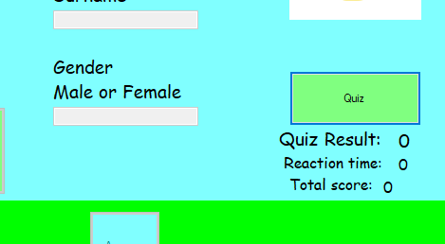
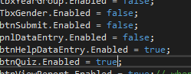
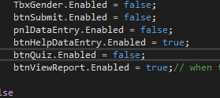
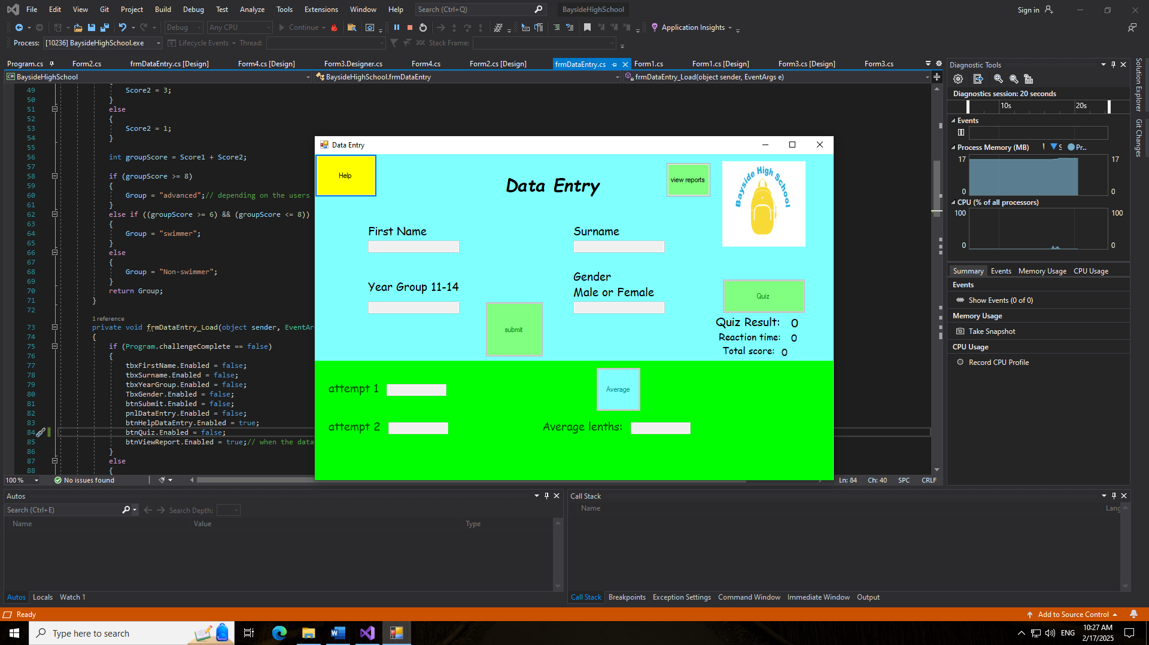
Fixed- The quiz button is enabled on load.
After- The Quiz button is now enabled when opening the data entry form
Before- The Quiz button is disabled in the load event.
Problem- The quiz button is disabled.
Test 9
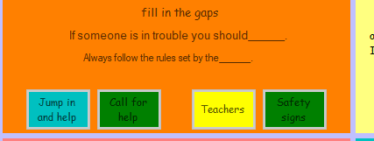
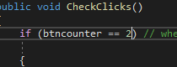
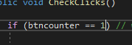
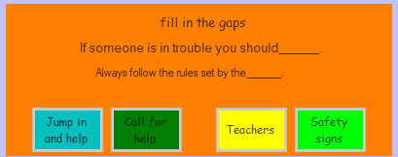
Fixed- Both correct answers can be press before the buttons are disabled.
After- The btncounter is set to two so another button can be pressed.
Before- The btnCounter was only set to 1 instead of 2.
Problem- Only one button can be pressed before they are all disabled.
Test 7
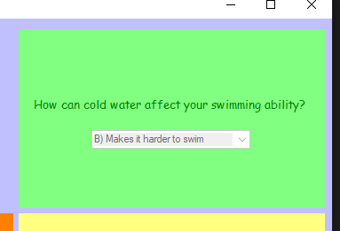
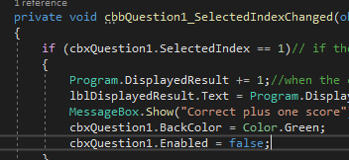
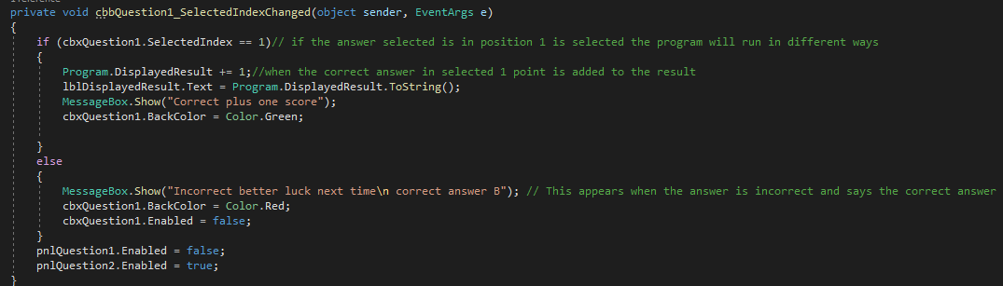
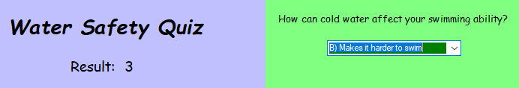
Fixed-pnlQuestion1 is disabled after the question is answered.
After- The code is added so it will be disabled.
Before- The code for the correct answer is missing a line to disable the combo box.
Problem- The combo box isn’t disable after the correct answer is inputted.
Test 27
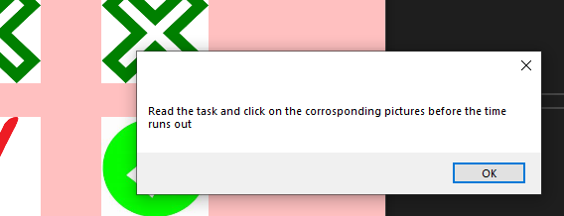
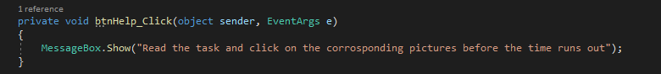
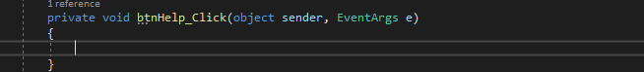
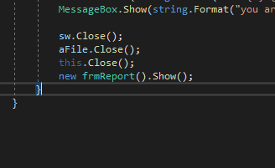
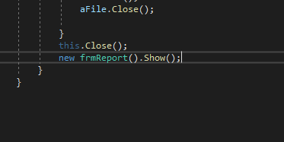
Fixed- The help box now shows up when the button is clicked.
Broken- The code for the help button had not been added so the message box didn’t show up to tell the user what to do.
Test 21
After- The code is in the if statement and will only run when the requirements are met.
Before- The code is outside the if statement and runs no matter what.
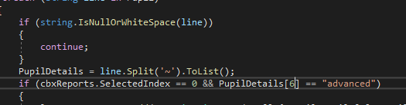
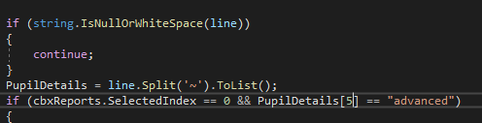
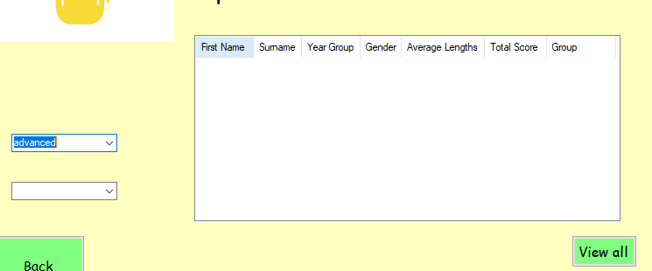
Test 37
After- The column has been changed from 5 to 6.
Before- The code is checking the wrong column for the data.
Broken- The entries for advanced don’t appear.
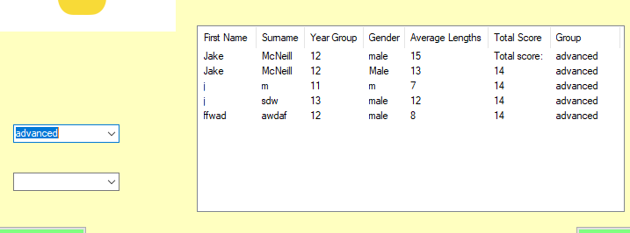
Fixed- The entries for advanced now show up when filtered.

Evaluation

User Requirements
User Req. Number | User Requirement | Evaluation Findings | Refinements and Improvements Following Testing and further improvements
1 | The user has to have a password and their username to get passed the log in form. | Fully met, the user does need to have the password and even if only one is not entered an error message will appear telling the user that they have entered their login details wrong. See tests 1 to 3 for more details if I had more time, I could have mode more usernames and passwords because currently there is only one correct password and username. | I moved the position of the textboxes for the username and password so that it is more centred and clearer to see where the details must be added in to make the form easier for the user to navigate.
2 | The user has to have the number of lengths they did for attempt 1 and 2 so they can average it so it can go towards their total score and their group. | Partially met, the program doesn’t accept the values if they are left blank or are letters however the program still has no way to confirm numbers so unrealistic answers can be inputted such as 10000 for more see tests 28 to 31. | I separated the attempts and average from the user details so that it is easier to find anything that is required on the form by using a panel to keep both separate.
3 | The user must have all of the correct details that need to be added to the data entry form. | Fully met, there are boundaries in the program that stop unrealistically long names form being entered such as a name 15 letters long would be accepted however a name that is 16 letters long wouldn’t cause an error to appear saying that the details have been entered incorrectly. If I have more time, I would have used a wider variety of ways to enter details other than just textboxes such as a combo box for gender for more see tests 24 to 27. | Originally even if details were entered wrong the user would still be sent to the reports form due to an error in the code where some code was placed in the wrong place causing it to avoid being affected by the if statement in the submit button to fix this I moved the code into the right place so that it only moves the user to the reports form if all of their details have been entered correctly.
4 | The user must be able to get pop ups to tell them what they did wrong or tell them what they are supposed to do and progress with buttons. | Fully met, there are button that allow the user to progress through the entire program such as being able to move from the data entry form to the reports form vice versa. And there are help buttons that tell people what they have to do in the form and when an error occurs a pop up appears to tell the user exactly what they did wrong. For more on this requirement see tests such as 32 to 34. | Originally there were less buttons to navigate the forms and there were less help buttons however if I had more time, I would make the help more detailed and make the error messages more specific, so it is easier for the user to fix any mistakes that they made on the form and make it easier to get though the program.
5 | The user must be able to answer all questions in the program. | Fully met, all of the questions have easy to figure out answers that can be answered by the user through the use of buttons, combo boxes, picture boxes and textboxes. For more on the questions see the tests on the quiz form from 7-18. | If I had more time, I would have used a different function to answer question 4 because it is inefficient to have to type one of 2 words instead of just selecting an answer and there is no code to give a different message if a different word than the words given is typed which is a problem because if someone accidentally makes a mistake in the spelling they will still get the question wrong.
6 | The user must be able to change the form by pressing buttons or by interacting with the other features such as combo boxes. | Fully met, the user is able to change things about the form to show them specific information for example on the reports form the user can see all of the data of the people that used the program or they can sort it using the combo boxes to only see people that are in a specific group and they can sort it into order by clicking the top of the Columns. For more see tests 35-38. | Originally, I wanted to add more ways to sort through the data however to not clutter the form I decided to do less combo boxes for the most important details such as the year group and the group of the students who have entered their details.

Performance During Testing
When testing the program I went through each form while making sure to test every feature in multiple ways so that I could find out if it fully worked for example when testing the quiz button was disabled when I opened the data entry form because there was a load event that would disable it the moment the form was opened so to fix it I had to change the true to false so that the user could access the quiz form and progress the program. I tested the program with unit testing making sure that each feature separately and detailing what happened and what data was entered in the testing section. I also used integration testing for certain parts of the code such as the submit button in the data entry form which relies on the text boxes for the first name, surname, gender and year group. An error that I found in the submit button was that even if unrealistic information was entered or no information at all it would still allow the user to progress to the reports form because the code to stop the user was located in an if statement but the code to progress was outside of the if statement and wasn’t affected so to fix it I moved the code into the if statement. Finally, I did a system test on the entire program to make sure that all the features could work together to allow the user to compete all of the questions and get through the entire form without errors and to be sure I got another person to go through the solution and they didn’t encounter any errors when progressing through the forms.

Performance and Robustness
When I was testing the solution, I did multiple tests on each of the features for valid, invalid, null and extreme data. When I was testing for valid data, I made sure to enter the correct information which fell within the boundaries of the code such as in the data entry form, I entered a name less than 15 letters long for the First name so that it would be accepted by the code when the submit button was pressed which it was. When testing for invalid data I entered the wrong details even if only slightly off to make sure that the solution wouldn’t let the user progress if the wrong information was added for example in the login form, I entered the username- username1 which wasn’t accepted when I pressed the login button because it didn’t include a capital U. when testing for null I just left the textbox blank such as for question 4 of the quiz I left the textbox blank and when I clicked the enter button to submit my answer it said that the answer had not been entered and that I had to enter an answer. Finally, when testing for extreme data I entered data that was on the boundary such as I entered a first name that was 15 letters long and a surname that was a single letter to see if the program would accept it and it did. I also tested the attempts and average for extreme data by entering 1000 into attempt 1 and 2 and although the numbers are unrealistic, they were still accepted by the program and gave an average of 1000.

